Analyze the application - which Microservice best practices does it not follow?
The following aspects need to be improved in the application:

- The logs shouldn’t written to a file, but to the container output.
- It should be stateless, so that:
- it can easily be restarted without loss of data,
- it is easy to spawn multiple instances of the application.
- Requirements installation should be moved from runtime to build time.
- App should be able to be executed both during development, with debugging enabled, and in production, with debugging disabled.
- The application should be built in such a way that the database can easily be replaced (development with production instance).

The logs output
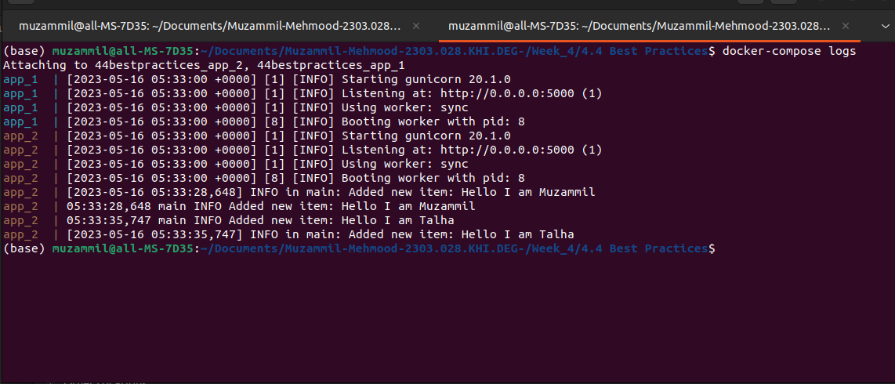
It is stateless as after stopping the docker container by using docker-compose down
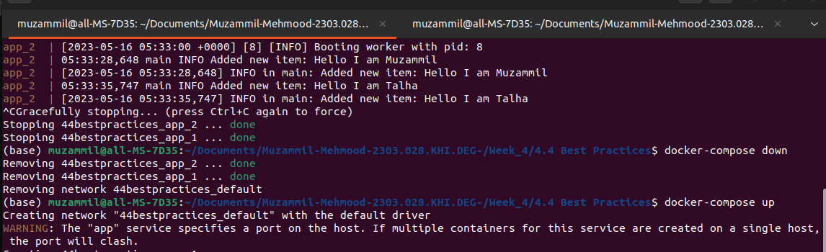

It is still retaining the data

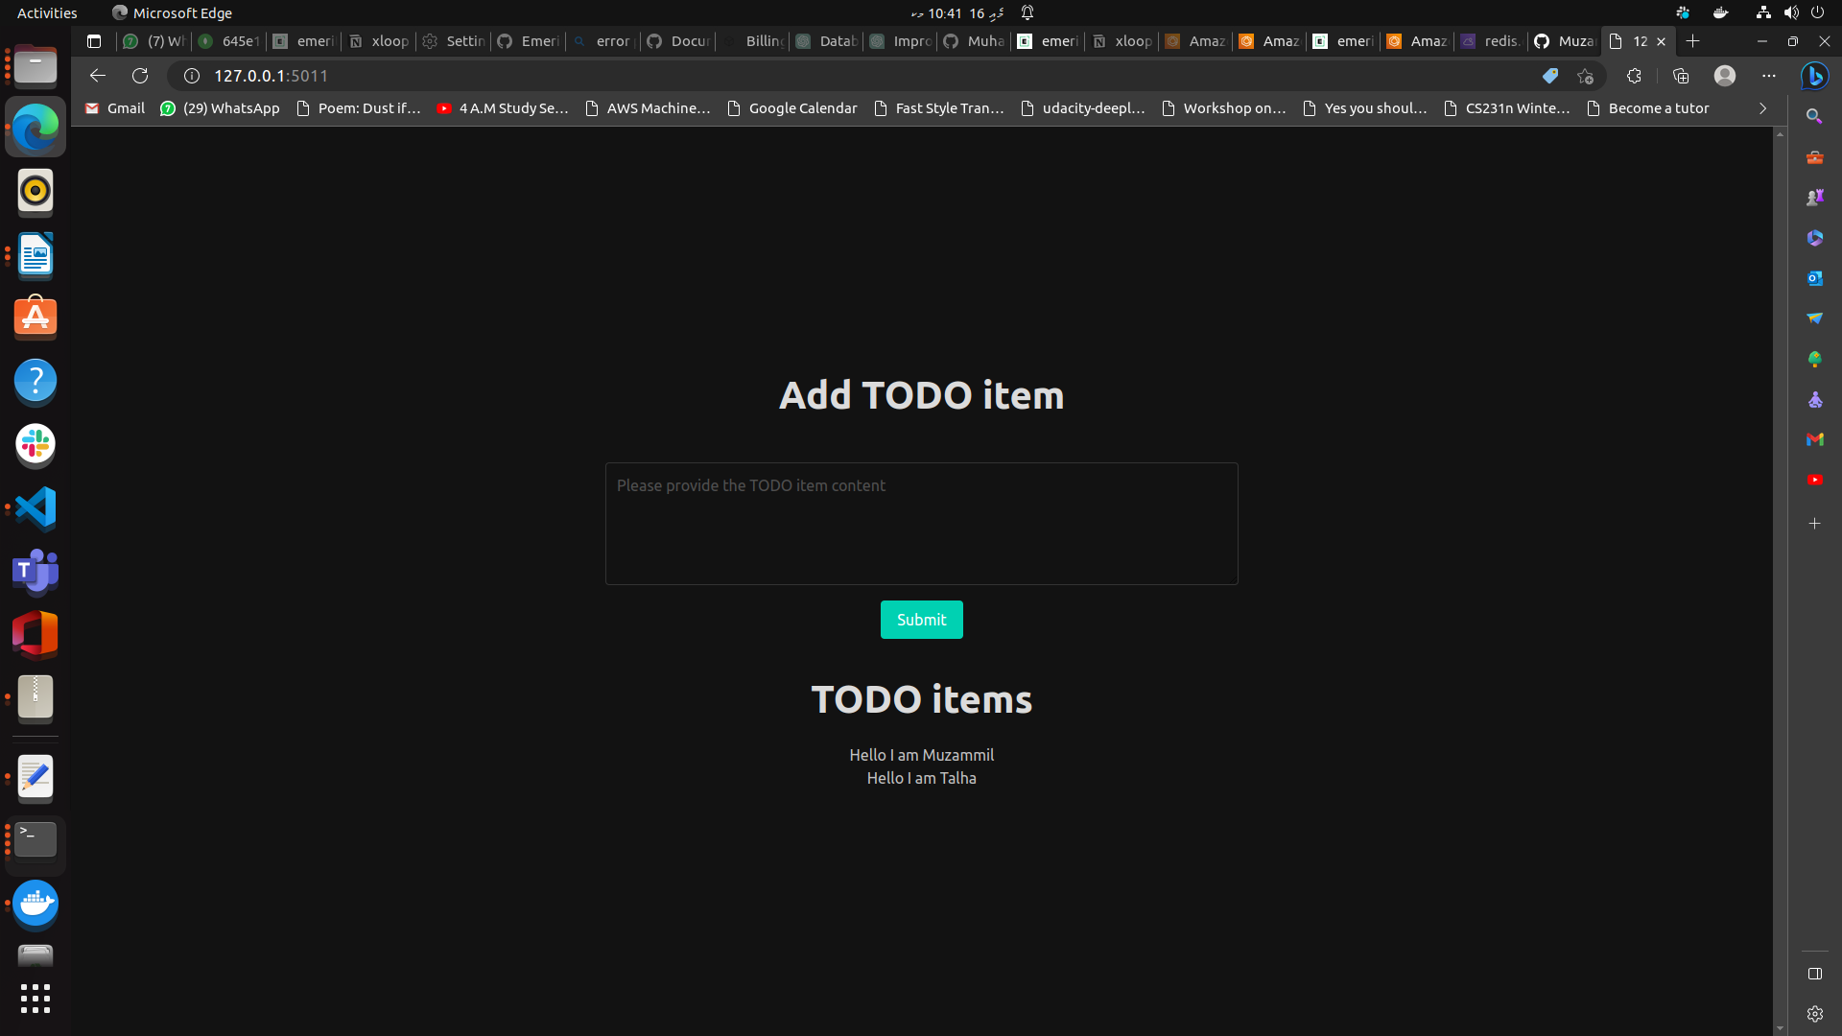
It is replicating on multiple ports,
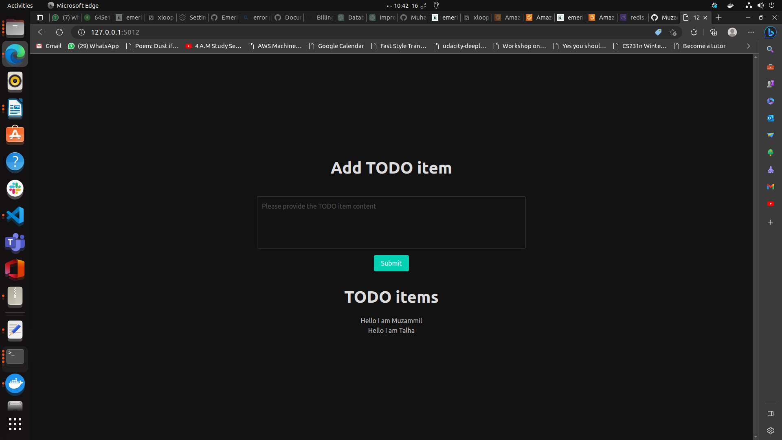

Other things can be verify by seeing the code

